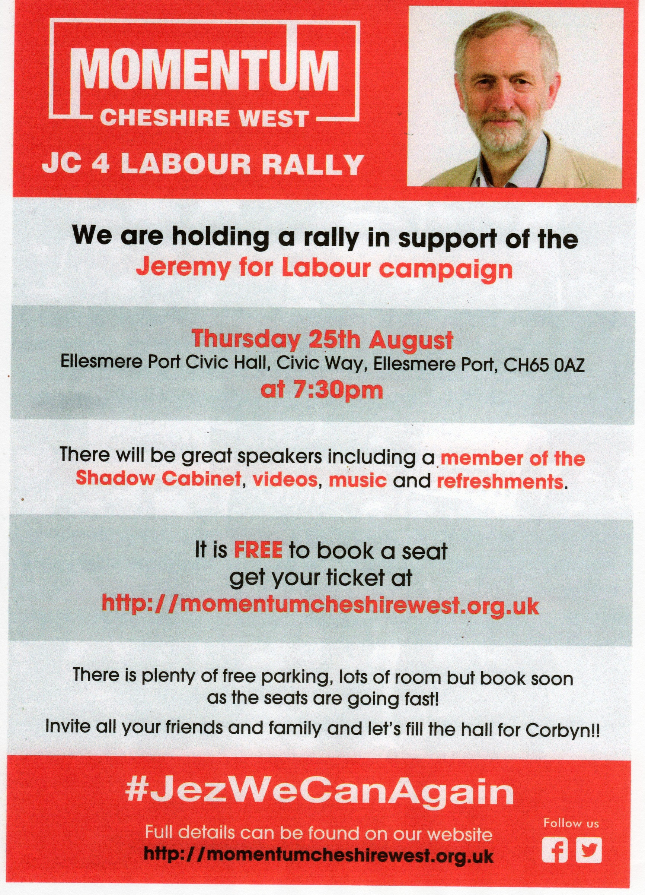

**Rally in Support of :**

**Jeremy Corbyn for**

**Labour Party Leader**

**7.30 pm Thursday 25th August**

**Ellesmere Port Civic Hall, Civic Way, Ellesmere Port, CH65 0AZ**

-------------------------------------------------

**Speakers include:** **Margaret Greenwood MP** **(West Wirral)**

**Tony Kearns** (**CWU** **Deputy General Secretary)**

Paula Barker (**UNISON** **NW Regional Convenor)**

**Stalls, Videos, music, refreshments, free parking**

**Book your FREE seat via Eventbrite.co.uk or see website below.**

**Entry will be available on the night. (Finish by 9.30 pm)**