Your Branch Officers:

Branch Secretary
Paddy Cleary

Asst Branch Secretary
Sue Mathie

Branch Chair
Sue Kellett

Vice-Chair
Steve Bennett

Treasurer (Acting)
Angie Redgrift

Negotiator
Brenda Hall

Communications Officer
Vacancy

Education Co-ordinator
Ian Upton

Equalities Officer
Karen Noonan

Health & Safety Officer
Nick Bower

International Relations
Phil Hamilton

Lifelong Learning Co-ord
Dave Hardcastle
Gill Whitfield

Membership Services
Ian Ward

Sports & Social Officer
Matty Moores

Welfare Officer
Angie Redgrift

Womens Officer
Rebecca Call

Young Members Officer
Hannah Plimley

Contact us at:

UNISON Branch Office,
Bebington Town Hall Annexe, Civic Way, Bebington,
Wirral, CH63 7SF

Tel: 0151 643 7007
Fax: 0151 643 7017
Email: unison
@wirralunison.co.uk



Meet Paddy Cleary Your New
Branch Secretary

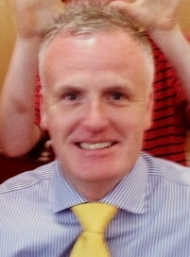

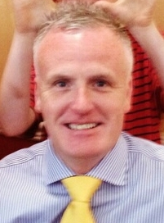

Hi, I am Paddy Cleary and I was the Branch Treasurer of Wirral UNISON until I was successfully elected to be your new Branch Secretary at the Branch Committee on 15 July.

I have had many years experience as an active UNISON steward and more recently as the Branch Treasurer, with my background being working in different Finance sections of the Council. This expertise will mean that I can lead the Branch through the difficult years ahead, with regard to any budget proposals and the potential impact these may have on our members and the services we provide.

The Branch is facing incredibly challenging times. Wirral Council is faced with a further £70m in cuts over the next three years or even £120m in line with the Councils 5 year 2020 plan (£60m in Growth and £60m reduction in grant funding). The Council is already talking about coming back for further cuts to terms and conditions. Job Evaluation is back on the agenda. Facility time is part of Governments attack on trade unions.

George Osborne, Chancellor of the Exchequer only last week announced that there will be another 1% cap on pay rises for the next 4 years. The IFS say that Public Sector Pay v Private Sector Pay will be at its lowest for 30 years come 2020!

That is why we MUST improve our influence of the Labour Group so they think twice before attacking our terms and conditions.

I will use skills obtained in my working life to obtain the best for our members in the continued fight we all face. I will break down and question budget proposals and co-ordinate all branch negotiations and industrial relations matters so we have a consistent approach. I will strive to protect our member’s terms and conditions and seek to maintain jobs.

We must have a voice in any devolution of powers to the Merseyside region and I will speak up for Wirral on any regional meetings that are likely to take place.

Over the last few weeks I have been out to schools and colleges and I have taken on board suggestions from core and non- core stewards, as well as discussed issues at length with Magenta and Wirral Autistic stewards.

We do many things very well, but there are areas where we could improve and I give you my commitment that I will do all that I can to achieve real improvements to our branch.

One of the first things I intend to do is to re-establish the branch website as this is an important avenue for communicating with our members. I will endeavour to use the media to highlight issues we face and to get our voice heard.

Most of all I will be open, honest and transparent in order to obtain the best for all our members.

